**Harbin Snow Festival**

The Meaning of the Harbin Snow Festival

The festival dates back to Harbin's traditional ice lantern show and winter garden party, which began in 1963. It was interrupted for a number of years during the Cultural Revolution, but was resumed when an annual event at Zhaolin Park was announced on January 5, 1985.

In 2001, the Harbin Ice Festival was merged with the Heilongjiang International Ski Festival and had a new official name, the Harbin International Ice and Snow Sculpture Festival.

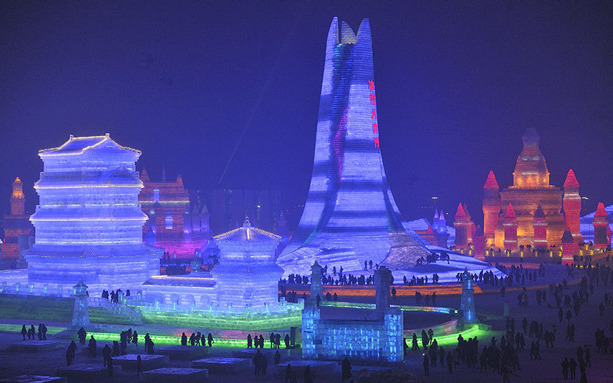

Harbin Snow Festival time

In 2015, the 31st Harbin Ice and Snow Festival opened on January 5 with the theme 'Harbin Ice, the Chinese Dream captivates around the world [' with the opening ceremony, fireworks display. , ice lanterns, birthday parties, snow sculpture competitions and exhibitions, as well as winter swimming, winter fishing, group weddings, fashion shows, concerts, ice sports games from December 22, 2014 to the beginning of March 2015.

Harbin Snow Festival venues

Harbin Snow Festival is an annual festival in the city of Harbin that is one of the four largest snow and ice festivals in the world along with the Sapporo Snow Festival, the Québec City Winter Carnival and the Norwegian Ski Festival. The festival was first held in 1963 and was interrupted for several years during the Cultural Revolution, then restored in 1985.

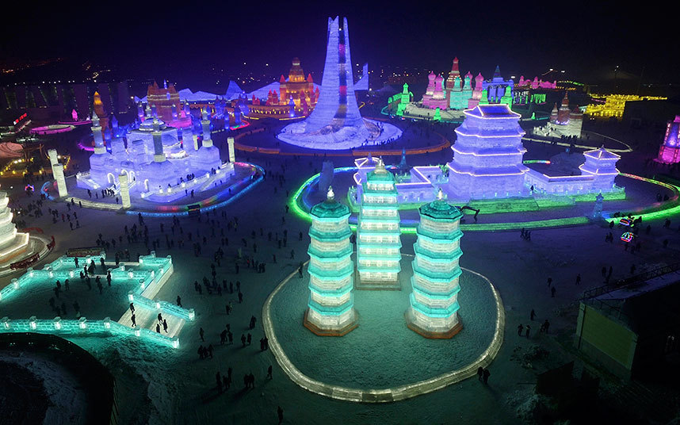

The Harbin Ice and Snow Festival is an annual event, but this year was a bit more special as 43 couples on this occasion held a mass wedding themed on snow and ice at the festival in Heilongjiang city, this northeastern part of China.

The Harbin Ice and Snow Festival, with its glittering castles and magical ice-sculpted scenes, has drawn millions of tourists over the years to one of China's coldest cities.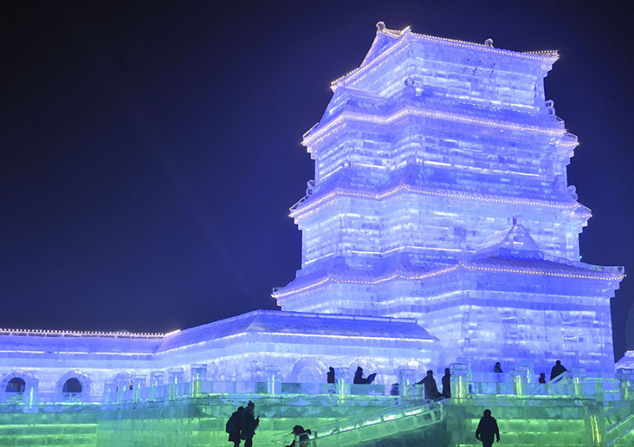

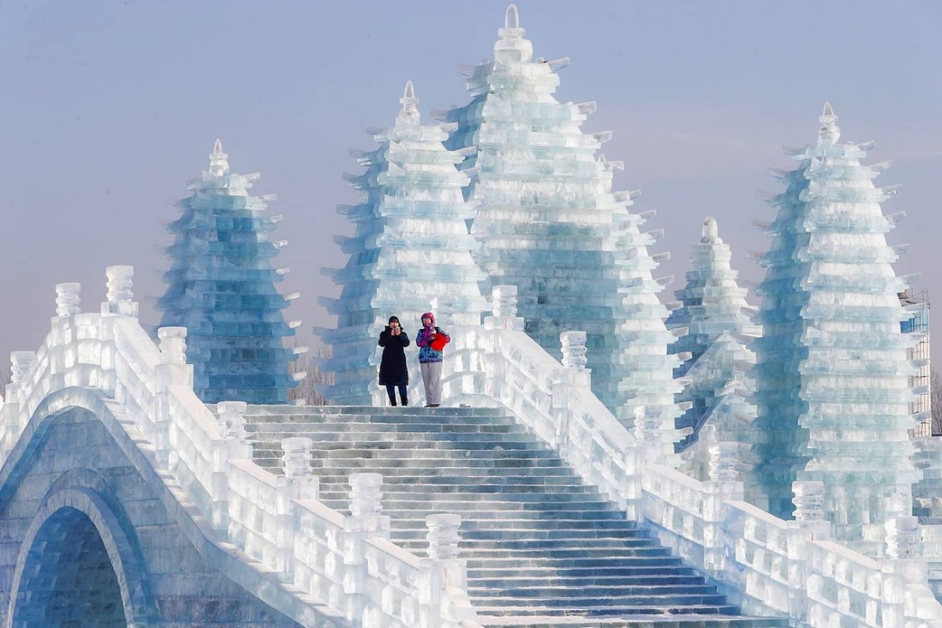

The works at the festival are created from about 170,000m3 of ice taken from the Songhua River.

More than 100 workers worked hours on ice every day for weeks before the opening of the festival to create beautiful ice sculptures.

